  

**Embedded System**

**Lab 02**

**By :**

**Jaser E Abu Ramadan**

**120200197**

**Submitted to :**

**Eng. Amal Abu jasser.**

**27/11/2024**

You can check the run time   
for the code

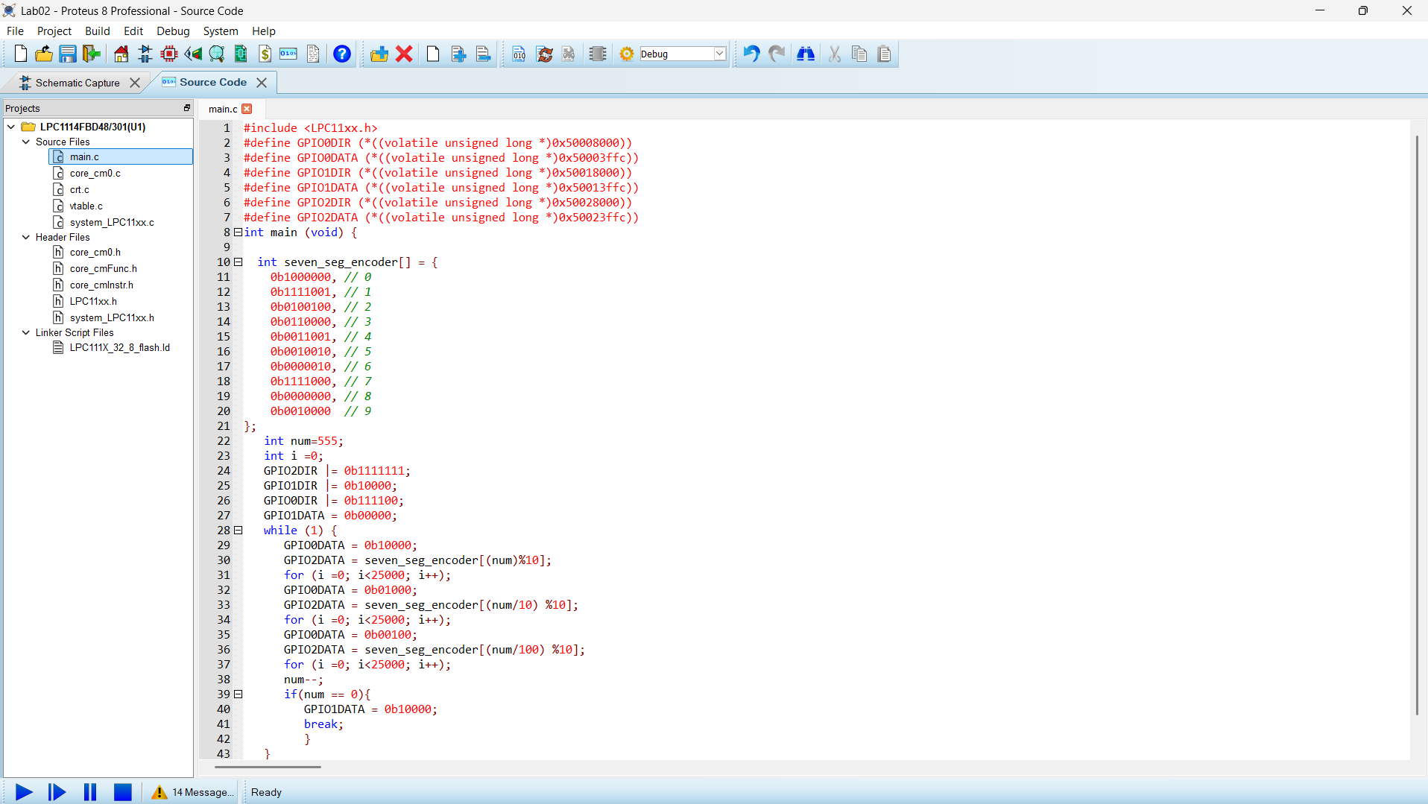

Thank You